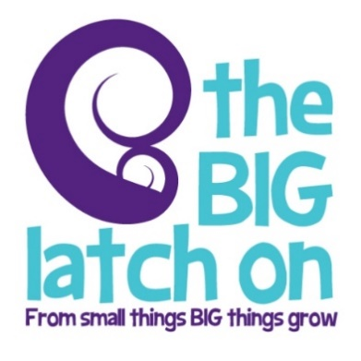
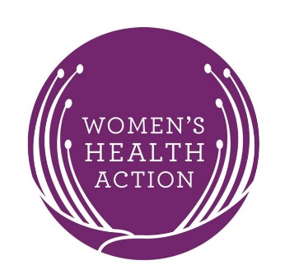

NEWS RELEASE – FOR IMMEDIATE RELEASE

Kiwi mums leading the 25th-anniversary Breastfeeding Celebrations

New Zealander’s are in the lead when it comes to breastfeeding celebrations, and on Friday the 4th and Saturday 5th of August, thousands of Kiwi mums and children will be gathering at locations throughout Aotearoa New Zealand to kick off the 2017 World Breastfeeding Week celebrations. They will be joined by over 40,000 women and children globally who are taking part in the annual Big Latch On to celebrate, support and promote breastfeeding.

2017 marks the 25th anniversary of World Breastfeeding Week, and this year it is all about working together for the common good ‘Sustaining Breastfeeding Together’. Breastfeeding practices differ across the globe, and with 27 countries and over 750 locations celebrating the Big Latch On, we are able to showcase the diverse ways in which we feed our children.

[insert organization name here] have registered with the national organiser's Women’s Health Action, to host a Big Latch On event for our local mums at [insert event details here …where, date, time].

This is our [insert number of years] year of hosting the Big Latch On, says local host [insert your venue spokes person’s name], and we warmly welcome and encourage all our local mums and their family, whanau and friends to join this fun and supportive event”

(Include if applicable) We will have [insert more information about your event – e.g goodie bags, activities, prize draws sponsors]

The Big Latch On is now in its 13th year, and in 2016, 1951 women and babies took part at venues or online through the #BrelfieNZ campaign.

Women who are unable to make it to a venue can take part virtually via #BrelfieNZ, flooding Facebook, Instagram and Twitter with gorgeous and diverse breastfeeding selfies – Check out www.biglatchon.org.nz for more information about national events.

ENDS

For more information on your local Big Latch On event call:
[insert your details here]

For more information on The Big Latch On nationwide contact:
Women’s Health Action, ph: 09 520 5295, email: info@wha.org.nz
For urgent contact: Isis McKay, Women’s Health Action Maternal & Child Health Promoter, ph: 021 442 450

