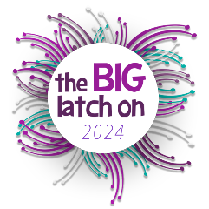
The Big Latch On 2024 Registration Form
(circle one) Friday 12th / Saturday 13th / Sunday 14th April 2024

Ko te mana o te whāngai ū, ko tā te whānau whānui

“Supporting breastfeeding helps whānau and communities to flourish”
Venue name & address: |  |  | Venue number:
Host name: |  |  | Host email:
All parents participating in the Big Latch On 2024 must complete this registration form
 | Name  Please PRINT  (Everyone attending and volunteering to sign in) | Email | Participants  Total number of people attending the event with you (including children and supporters) | Photo consent (sign if you agree) *See below | Please tick if Big Latch On & its partners can stay in touch?
1
2
3
4
5
6
7
8
9
10
*Photo consent – I authorise use of my own and my child/children’s visual image and statements in newsletters, posters, internet and other advertising to promote breastfeeding and the Big Latch On
Witness/Host statement: Please upload the total number of participants at your location through host website
Total number of participants at this location: ______ and scan & email this form to the BLO Organisers at events@wha.org.nz
Name (print): ____________________________________________ Signature: ________________________________

